Task 2

1. **Target Device:** The platform for this game is Windows.
2. **Gameplay Flowcharts: darren or daniel**
3. **Game Mechanics: daniel**
4. **Game Objectives:** The objective of this game is for the player to try and collect the spaceship parts without being caught from the enemy AI so he can escape.
5. **Visual Assets :**

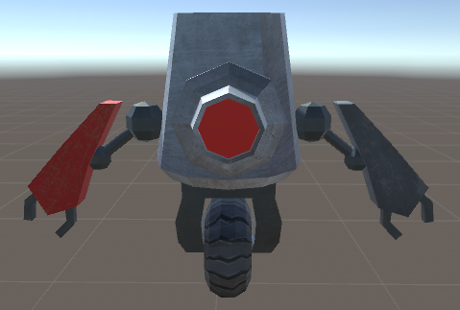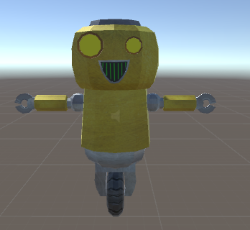

Model 2: Enemy (The enemy model)

Model 1 : Roll-E (The player model)

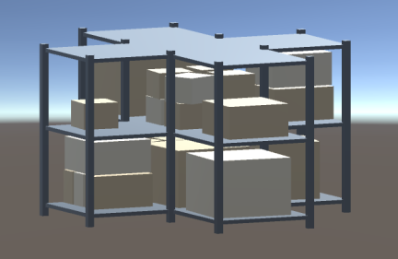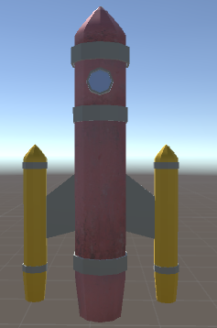

Model 4 Shelves-1

Model 3: The rocket ship

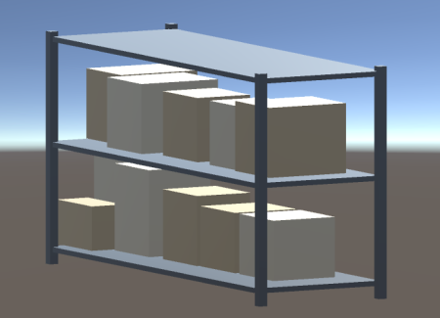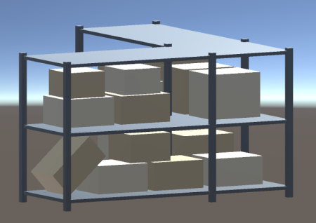

Model 5 Shelves 3

Model 5 Shelves 2

1. **Ui Elements :**
2. **Game Scenes :**